MCP for Document Knowledge Bases

1. Framework (LangChain + Anthropic) LangChain handles the boring parts — loading PDFs, splitting text into chunks, and running embeddings. Anthropic's voyage-3 model creates the embeddings. ChromaDB stores them locally (no server needed to start).
2. Schema Design — two entities
- Document — the whole file (title, source, topics, metadata)
- Chunk — a 500-char slice of a document with an embedding vector and a score field that gets filled at query time
3. MCP Tool Registry — 5 tools
Tool | Purpose
search_docs | Semantic search, returns top-k chunks
get_chunk | Fetch one chunk's full text by ID
list_topics | Discover what categories exist
get_document | Get document metadata
ingest_document | Add a new doc at runtime

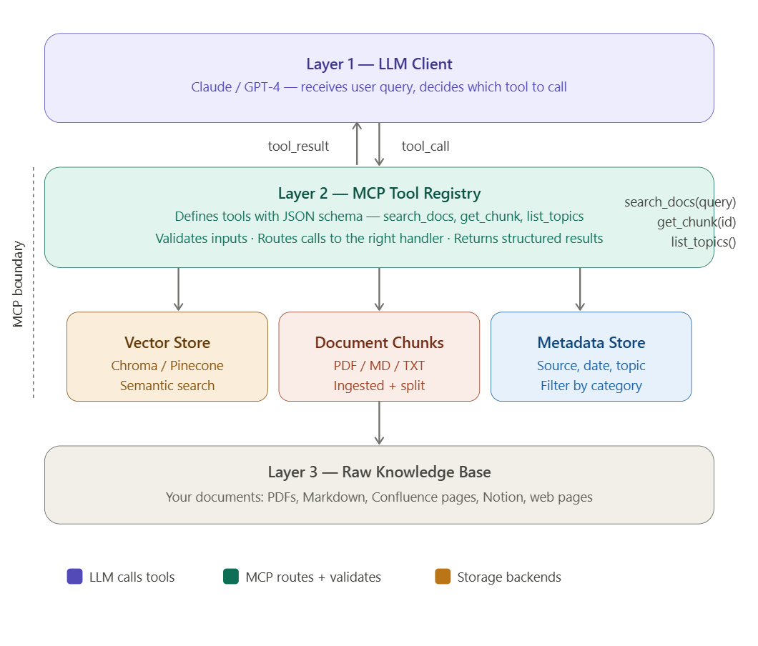
Without MCP & its challenges

When you just upload a file to Claude (or ChatGPT):
The entire file gets pasted into the context window. Claude reads it all at once and answers. Simple, fast — but it has hard limits:
- Works for 1–2 small files
- Fails when you have 500 documents
- No persistence — next conversation, it's gone
- You can't search across files or filter by topic
- Every query costs tokens for the entire document, even if only 2 paragraphs were relevant

When you build an MCP knowledge base:
Your documents live in a vector database permanently. The LLM doesn't read everything — it calls a tool, gets back only the 3–5 most relevant paragraphs, and answers from those. This means:
- Works for thousands of documents — a full company wiki, all your PDFs, years of notes
- Persists forever — ingest once, query forever
- Cheap — only relevant chunks are sent to the LLM, not the whole corpus
- Filterable — "search only HR documents from 2024"
- Updatable — add new docs without re-uploading anything
- Shareable — your whole team or app can query the same knowledge base via API

The real-world analogy:
Uploading a file to Claude is like reading a book aloud to someone before asking them a question. It works for one book.
An MCP knowledge base is like giving someone a library card and a search engine. They find exactly what they need, from any of 10,000 books, instantly.

So when do you actually need to build this?
Situation | Use upload | Use MCP knowledge base
1 PDF, one-off question | ✅ | overkill
50+ documents | ❌ won't fit | ✅
Company internal wiki / docs | ❌ | ✅
Product you're building for users | ❌ | ✅
Needs to stay updated over time | ❌ | ✅
Multiple people querying same data | ❌ | ✅
You build the MCP knowledge base when the problem is too big, too persistent, or too shared for a simple file upload. That's the whole point — you're building infrastructure, not having a one-off conversation.

OverView:

What is MCP for a Knowledge Base?

MCP (Model Context Protocol) lets you give an LLM structured, typed tools it can call — like functions with JSON schemas. Instead of pasting your entire document into the prompt, the LLM calls search_docs("what is RAG?") and gets back only the relevant chunks.

1 User asks a question
"Explain the refund policy from our handbook." — sent to Claude or GPT-4.

2 LLM calls a tool
Model sees available MCP tools and decides: search_docs(query="refund policy")

3 MCP server handles it
Your server embeds the query, queries ChromaDB/Pinecone, returns top-k chunks as JSON.

4 LLM synthesises the answer

Model reads the returned chunks and writes a grounded, cited answer back to the user.
Key insight: MCP is just a standardised way to define tools with typed schemas so any LLM can discover and call them. Your knowledge base becomes a set of callable functions.
What you build

A Python server that exposes 3–5 tools: search, fetch, list, summarise. Each tool has a strict JSON Schema so the LLM knows exactly how to call it.
What you DON'T need
You don't need to stuff your entire document corpus into the context window. The LLM fetches only what it needs, keeping costs and latency low.

Schema Design —

Documents + Chunks
Before writing any tool, design your data model. You need two entities: Document (the whole file) and Chunk (a split paragraph with an embedding).

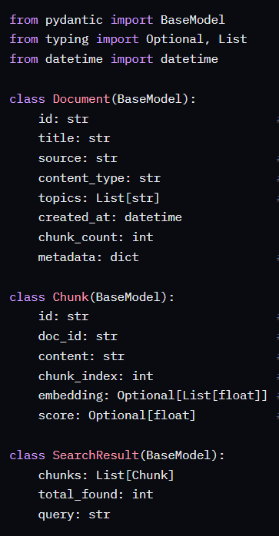
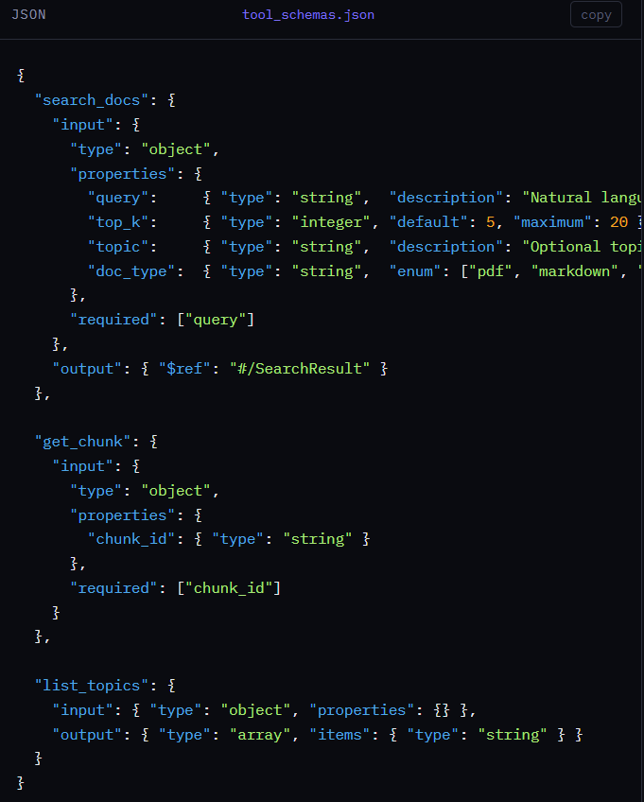

Tool Registry —

The tool registry is the central list of what your MCP server can do. Each entry has a name, description (read by the LLM), and a JSON schema for inputs.

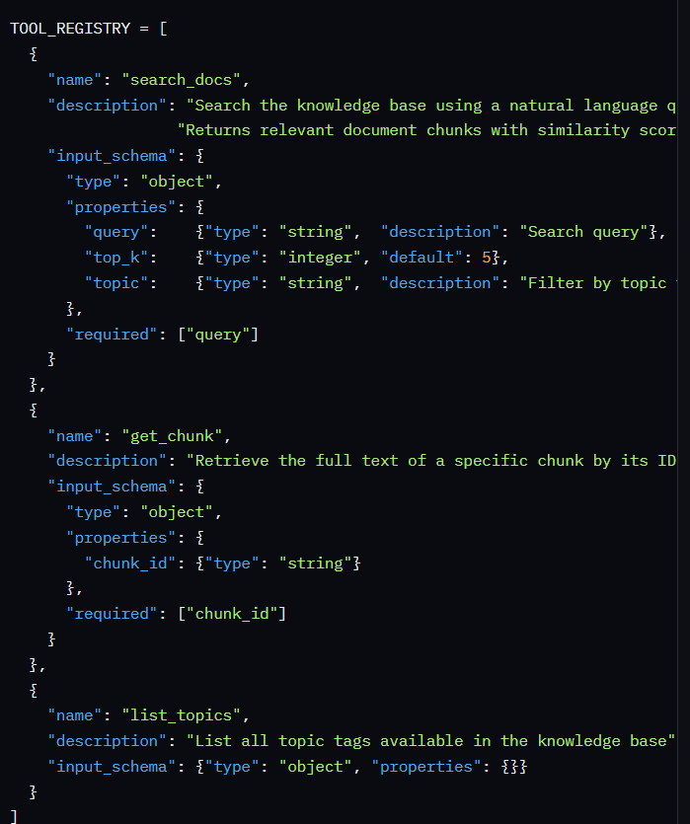

Document Ingestion Pipeline
Before tools can search anything, you need to load, split, embed, and store your documents. This is done once (or whenever docs change).

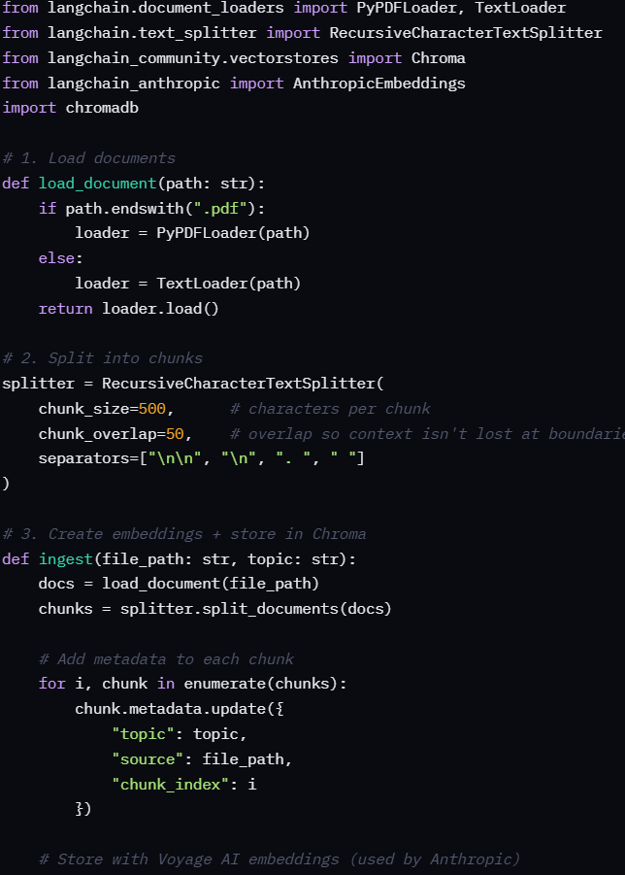
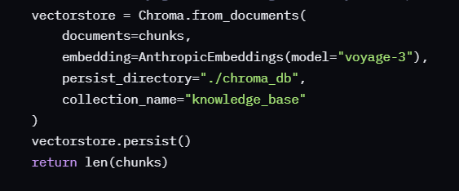

MCP Server —
The server exposes your tool registry over stdio (or HTTP). Claude/GPT-4 connects to it and calls tools. Use the official mcp Python SDK.

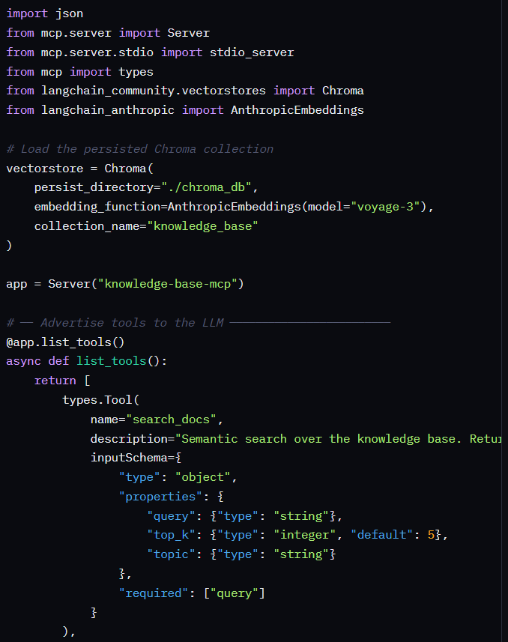
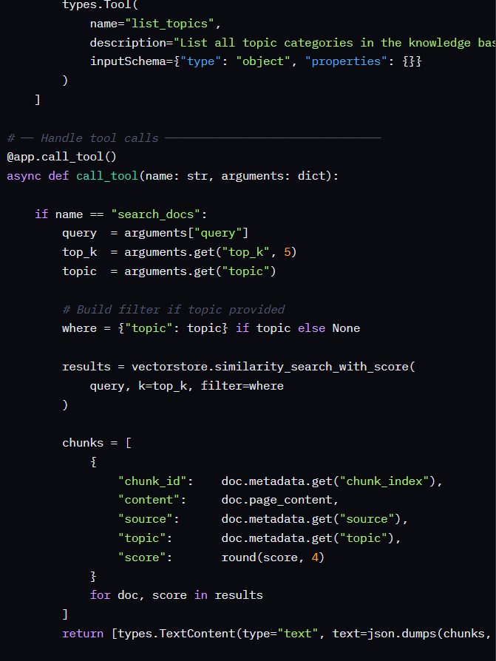
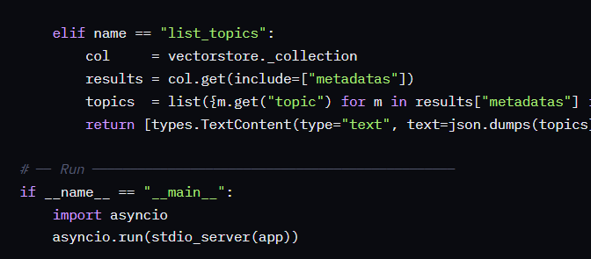

Client — Connect Claude to Your MCP Server
Use the Anthropic Python SDK to connect Claude to your running MCP server and ask questions that trigger tool calls automatically.

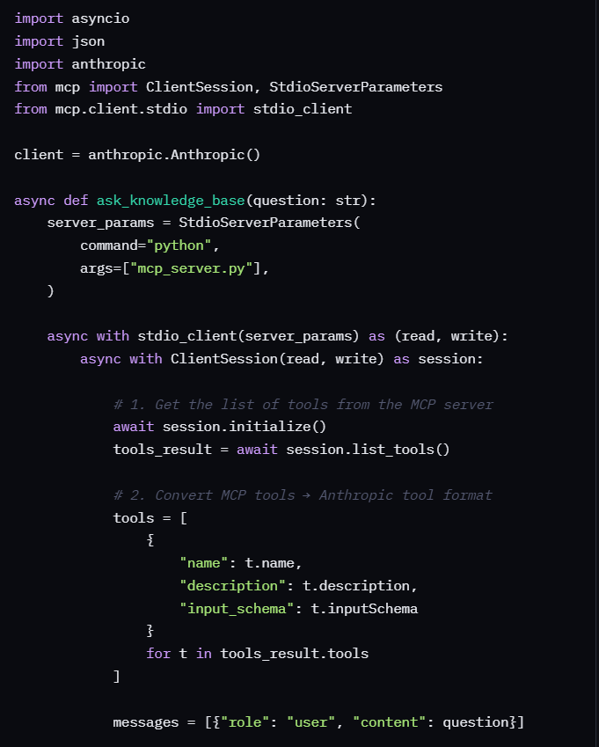
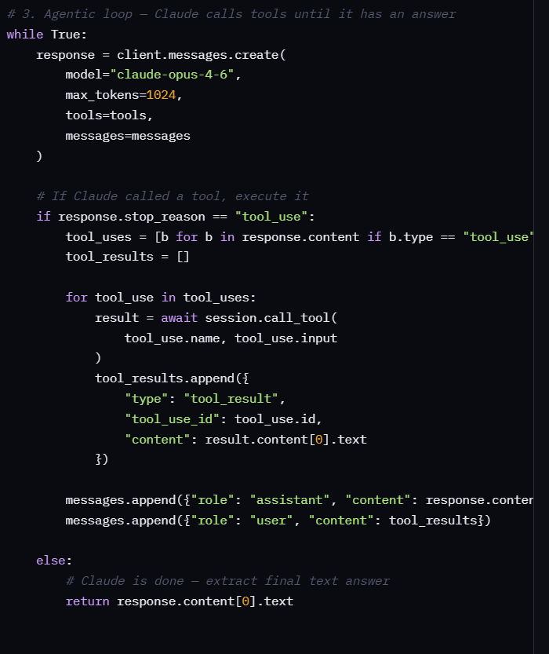
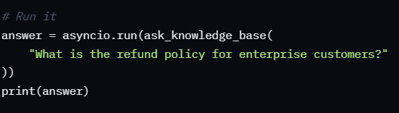

Testing:
File Structure

MCP1/
├── 📄 ingest.py ← Reads documents → Creates embeddings
├── 📄 qurey.py ← Uses API key → Calls Anthropic
├── 📄 validate_system.py ← Tests without API key (LOCAL)
│
├── 📄 mcp_server.py ← MCP SERVER (your code)
├── 📄 mcp_server_stdio.py ← MCP SERVER (your code)
├── 📄 mcp_config.json ← MCP CONFIGURATION
│
├── 📁 chroma_db/ ← Vector database (embeddings stored)
├── 📁 docs/ ← Your documents
│ ├── hr_policy.md
│ └── product_faq.md
└── 📄 MCP_SETUP.md ← Documentation

How It works

PROJECT CODE
↓
┌──────────────────────────┐
│ │
v v
ingest.py mcp_server.py (MCP)
(reads docs) (exposes tools)
↓ ↓
Embeddings ChromaDB queries
↓ ↓
chroma_db/ Returns search results
(database) ↓
↑ ↑
└─────────────────────────┘
↑
┌──────────┴──────────┐
│ │
You run scripts Claude (ME)
qurey.py, etc accesses via MCP

Explaination

YOUR CODE (MCP SERVER):
├── mcp_server.py → "I can query ChromaDB"
└── mcp_config.json → "Connect me to Claude"

CLAUDE (ME):
├── Sees MCP server
├── Gets 3 available tools
│ ├── query_knowledge_base()
│ ├── list_topics()
│ └── get_document_count()
└── Automatically uses them when you ask questions

Work Flow:

What Happened When You Asked "How many leave days?"
Step 1: You asked me (Claude)
Step 2: I checked MCP server for available tools
Step 3: I called query_knowledge_base("How many leave days?")
Step 4: MCP server searched ChromaDB locally
Step 5: Found result: "18 days of paid leave"
Step 6: I returned the answer to you

Outputs:
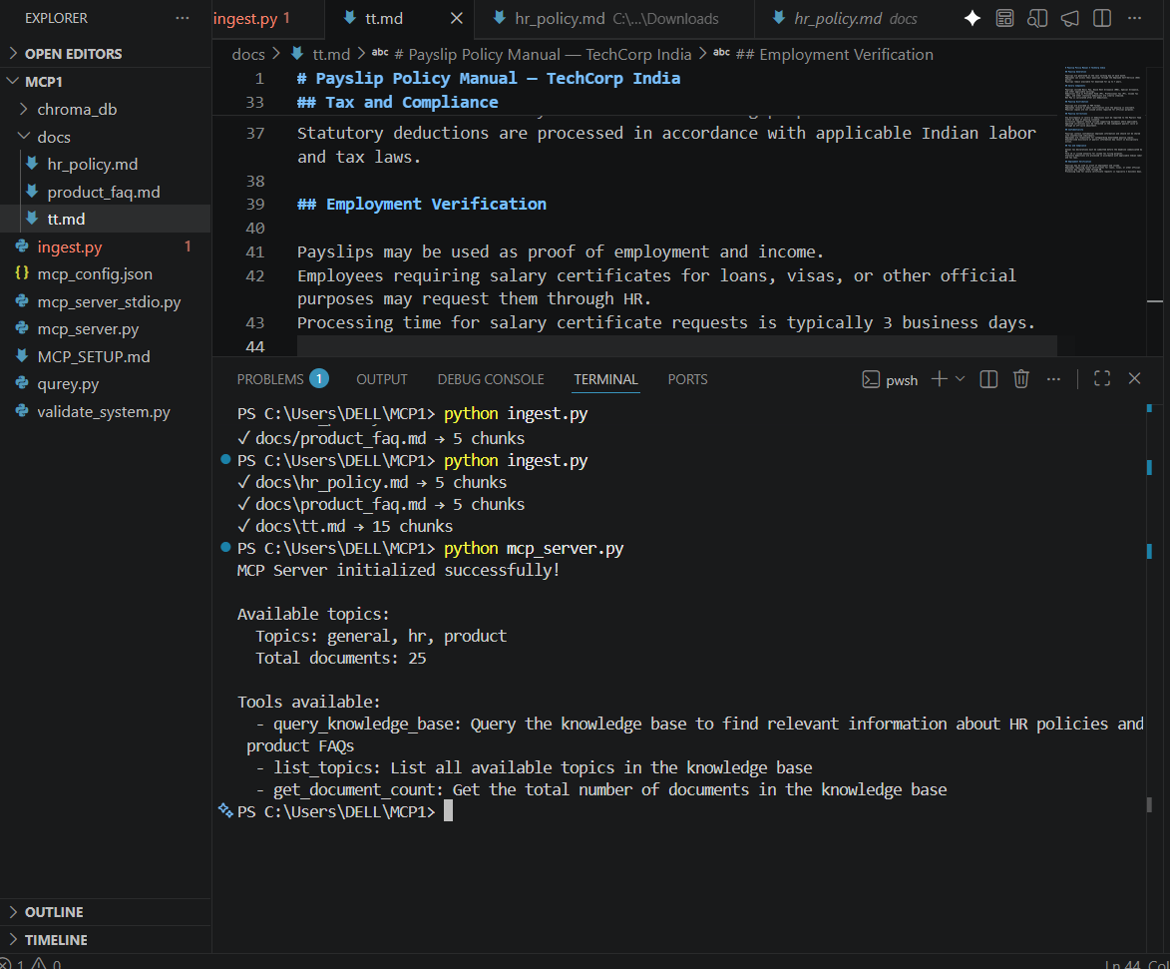

Questions:
"How many leave days do employees get?"
"What is the sick leave policy?"
"What is the onboarding process?"
"When are performance reviews conducted?"
"What is the bonus eligibility criteria?"
"What are the hotel reimbursement limits?"

"What are the pricing plans?"
"What integrations does SmartFlow have?"
"What is the API rate limit?"
"What security certifications does SmartFlow have?"
"What is the professional plan SLA?"
"What is the enterprise plan SLA?"
"Where is data hosted?"
"When are payslips generated?"
"How long can employees download their payslips?"
"What are the salary components on a payslip?"
"What should I do if there's a discrepancy in my payslip?"
"How long does it take to get a salary certificate?"
"What is the deadline for tax declarations?"
"Can I use my payslip as proof of employment?"
"What deductions are included in payslip?"
"What is Form 16 and when is it issued?"
"How do I report a payslip error?"

